**Major Historical Markets Downturns and Five Factor Model**

Almost 11 years after the Lehman’s sudden collapse and the Federal Reserve bailing out AIG from the cliff edge, we are surrounded with voices saying that we are counting down to our next financial crisis in a year or two, although currently we are still safely moving forward with rosy economic indicators. Each crisis or market crash was extraordinarily damaging to households, social security and political stability, and may be triggered by various factors, including political affairs, internal economy, etc. As for how to navigate ourselves across the future unknown dark periods, history is a good place to look for answer. As the first AIG Investment AI quantitative research report, this research report will lay a foundation for more future research reports to come by giving a brief overview on the US extreme events that had big impacts on the equity market since 1960s. In the second part of this report, we will examine and discuss the performance and characteristics of one of the most popular financial models, the Fama French 5 factor model, in the past decades, especially when those “extreme events” happened.

[Type the document subtitle]

1. ***Historical Market Downturn Triggers***

***Economic Recession***

***1981-82 Recession***: In the 1970s, the Fed adopted a “stop-go” monetary policy, which is based on the trade-off between unemployment rate and inflation rate on Phillips Curve. In “go” periods, the Fed would fight unemployment by lowering interest rate, while in “stop” periods, the Fed would tighten the monetary supply for a lower inflation rate. However, in mid 1970s, the Fed seemed to lose its control over both inflation and unemployment as they tended to mount together. The unemployment rate reached its peak in May 1975 at 9% and trended down slightly in late 1970s. Believing that a high Inflation rate would be harmful to the economy over an even longer time, the Fed again tightened monetary supply after the inflation hit its peak at 11% in Jun of 1979. The expense is inevitably a rising long-term interest rate. 10-year Treasury yield was as high as 15% in 1981. Economic sectors that were more dependent on borrowing were drained, and unemployment rate started to climb to almost 11% at the end of 1982, the highest level in any modern recession. The recession corresponds to the bear market in 1981 – 1982. From Nov 1980 to Aug 1982, the S&P 500 index dropped by 27%.

***International Debt***

***European Debt Crisis***: The European Debt Crisis is a long-lasting crisis with complicated and varied causes. Take Greece, the first to trigger the crisis and most severe country, as an example, its major supporting industries (shipping and tourism) were largely affected by the 2008 global financial crisis. The Greek government spent aggressively to keep the economy from falling and finally the deficit was announced to be 12.9% of Greece 2009 GDP, a number way much higher than EU’s 3% limit. Being unable to repay its huge debt, and unable to further borrow from the market either with a junk-status in sovereign debt rating, the Greek government started to seek for bailout loans from EU and IMF.

A working paper from European Central Bank found that major transmission channels of the euro debt crisis to countries outside Eurozone were trade and economic links, while the financial channel turned out to be weak (Stracca 2013). Although US export to Europe only amounted 2% of US GDP, and nor US economic activities were tightly linked to the European countries with severe defaults, US could be affected indirectly by the crisis as other developed countries’ movements. Economist at Citigroup found that GDP growth of US and Europe were moving three times closer in 2000s than a decade before (Irwin 2011).

Beyond actual economic activities, market emotion is also contagious across the world. The spread out of risk-aversion emotion impact the decision-makings of both government officials and business leaders and each investor, which enhanced the correlation between markets around the world. For example, and US stock market moved in the same direction as German stock market 86% of the trading days in September of 2011.

***LatAm Debt Crisis***: Before the US could take a breath from a 2-year recession, in August 1982, Mexico announced that they were not able to service the debt to US commercial banks and other overseas creditors, and other Latin American countries followed with same announcements shortly. The Debt Crisis originated from the skyrocketed Latin American borrowing from overseas creditors in 1970s. By 1982, the total Latin American debt held by the 9 largest US banks was 176% of those banks’ capital. Coincide with fighting inflation as the priority of the industrialized world, the Latin American countries found that their debt burdens were gradually beyond their affordable level as the interest rate for loans climbed under the tightening monetary policy.

***Asset Bubble***

***Dotcom Crash:*** As the personal computer gradually became a necessity in 1990s, the era of information technology arrived, and a large amount of internet-related companies were founded accordingly. Meanwhile, interest rate lower than the prior decades when the Fed fought high inflation with tightening monetary policy provided a favorable environment for the new tech companies to raise capitals and expand their businesses. Investors were enthusiastic about buying in any stock with “.com” suffix in the company name. In order to sustain the technology effect and grab larger market shares, the dotcom companies spent aggressively on all kinds of marketing and promotions, and a lot of them consequently had to maintain operations under losses with more easy money raised from all channels. On March 10, 2000, the NASDAQ Composite stock market index, which included a lot of dotcom companies, peaked at 5,048.62.

However, the carnival partially arose from low interest rate could not sustain any more afterwards when economy slowed down and the interest rate started to increase. A lot of dotcom companies were shut down and liquidated, other more robust ones like eBay and Amazon, though survived, ended up with market capital evaporated by 86%. By end of 2002, the stock market lost 5 trillion dollar compared to the prior peak. At its lowest point of NASDAQ index in October 2002, NASDAQ dropped by 78% from its peak.

***2008 Financial Crisis***: The 2008 Financial Crisis is considered to be the most serious financial crisis ever since the 1930s Great Depression. However, tracing back to the very beginning, it was actually originated from some good intention of the government: in 1995, in order to encourage Fannie Mae and Freddie Mac to fulfill their lending obligations for affordable housing and reduce discrimination against low-income borrowers, the government started to allow them to buy subprime securities, among which Credit Default Swap (CDS), introduced by J.P. Morgan in 1994, was a notorious one during the later crisis.

The following ten years saw the government and financial industry gradually took on more risks: Fannie Mae lowering the credit requirements for low-credit borrowers in 1999, banks being allowed to run investment brokerages and other financial businesses, regulations on CDS trading being relaxed the same year, in 2004 the Securities and Exchange Commission’s removed the leverage limit for companies with larger than 5 Billion assets, and therefore top banks usually used thirty times leverage rather than twelve as restricted before. Meanwhile eleven interest rate cut was implemented after the Dotcom crash, and this further fertilized the soil of lending market.

However, starting from 2006, the housing market started to cool down, and in 2007 the decline accelerated. The subprime mortgage industry collapsed, with many of the lending companies declared bankruptcy. And shortly, the collapse was spread to the broader financial sector as many banks and hedge funds invested aggressively in mortgage-backed securities (MBS). The crisis quickly became a global one as banks and hedge funds from outside US announced liquidity problem due to their massive holdings of MBS. Bear Stearns, the second largest underwriter of MBS, was the first iconic Wall Street investment bank to collapse: the company firstly bailed out its internal hedge funds with billions of dollars, which was not unmanageable compar]ed to its 20 billion market cap at that time. But as the rating companies continued to downgrade tis MBS and other holdings and the bank run happened later on, it soon ran out of liquidity in the down market and J.P. Morgan finally acquired it with financial support from the Fed in March 2008. In September, Lehman Brothers fell. Lehman was the largest MBS underwriter, and with a MBS portfolio that was four times its shareholders’ equity, Lehman was more of a real estate hedge fund that an investment bank. Lehman’s bankruptcy triggered a 4.5% single-day drop in DJIA, the largest one since the 911 attack. AIG was afterwards been bailed out by the Fed to avoid other economic sectors’ meltdown.

The Fed rescued the economy by more bailouts in other industries, and 3 rounds of Quantitative Easing (in 2008, 2010 and 2012 respectively) by massively buying in government bonds and MBS. After these manipulations, the Fed’s balance sheet ballooned from 900 billion to 4.5 trillion. It was not until the Obama’s economic stimulus plan was released that the public confidence was rebuilt and the 2008 stock market crash was finally ended in July of 2009.

***Black Swan and Algo***

***Swiss Franc Crisis:*** Swiss Franc was always regarded as safe haven currency. Due to the long-lasting European Debt Crisis, the demand for Swiss Franc continued to increase, putting a strong pressure on Switzerland’s export, which contributed to more than 70% of Switzerland’s GDP in 2013. Switzerland decided to peg Swiss Franc at a 1.2 FX rate against Euros by printing Swiss Franc to purchase foreign assets and currencies when Swiss Franc appreciated beyond that cap. After three years of efforts to buying in massive foreign currencies, the Swiss National Bank (SNB) already grew a ballooned balance sheet. Meanwhile, as the Euro continued to depreciate against US Dollar, the SNB was faced with high risks of devaluation with Swiss Franc pegged with the weakening Euros, as well as risks brought by a soaring inflation within the country. The EUR/CHF exchange rate dropped 20% within 1 min after the announcement, and it was disastrous to most FX traders who ended up with huge negative balance sheet, as they paid huge to winners but were unable to collect from losers who largely traded with leverage. A working paper by the Bank of England found that during the Swiss Franc crisis, computerized algorithmic (Algo) trading consumed liquidity and reinforced the price disruption in Swiss Franc currency pairs while the human traders did the opposite (Francis Breedon, Louisa Chen, Angelo Ranaldo, Nicholas Vause 2018).

The Wall Street was undergoing uneasiness during the prior several weeks due to the glooming economic indicators in multiple sectors, and this Black Swan definitely compounded the pessimistic emotion. Especially after BOA and Citigroup released their glooming figures of earnings and returns in 2014Q4 and reported huge losses through the Swiss Franc crisis.

***1987 Stock Market Crash***: Monday, Oct 19 of 1987, is known as the Black Monday when stock markets around the world crashed. The crash firstly began from Hong Kong, and hit Europe afterwards and later on spread to United States. The US economy recovered from 1980s recession and the stock market was booming accordingly. The DJIA increased by 44% from 1986 year end closing point 1,895 points to 2,722 points in August 1987.

On October 19, the crash firstly occurred in Hong Kong. The DJIA dropped by 508 points or 22.6% on October 19, which still remains to be the largest one-day percentage decline in the DJIA. By end of October, the stock markets had fallen in Hong Kong by 45.5%, in United States by 22.7% and the UK by 26.5%.

The causes of this crash are still debated. But a most commonly blamed one is the growing and massive use of program trading, which would blindly sell or buy stocks as markets fell or went up and therefore created extra self-inflicted volatilities. Thus, people have reason to believe that the booming market right before the crash can also be attributed to program trading. This is also when the circuit breakers or “trading curbs” was introduced to prevent the index price from a free fall under program trading.

***International Political Factor***

***1973 OPEC Oil Embargo:*** In 1973, in order to gain leverage in the peace negotiations after the Arab-Israeli War, the Arab members of OPEC (Organization of Petroleum Exporting Countries) imposed an embargo banning petro exports to United States and other countries that supported Israel. Increasingly dependent on oil import, the US economy was drained as the oil price soared to double and finally tripled following the embargo. What made things worse was firstly the wage-price control implemented by President Nixon, who pegged the wage too high and forced businesses to lay off workers. And secondly a devaluation of US dollar triggered by Nixon’s taking US off the gold standard.

All these factors together led to a long-lasting stagflation and negative GDP growths lasted for 5 quarters from 1973 Q3 till 1975 Q1, and unemployment rate reached a peak of 9% in May 1975. The crude oil price remained high even after the embargo against US was lifted in March 1974. At the peak, the crude oil price was 6 times the mid-1973 crude oil price level as the OPEC cut production for several more times. Actually starting from January 1973, the stock market was already undergoing one of the worst downturns in the history, and it was compounded by the OPEC Oil Embargo later on. From January 1973 to October 1974, the S&P 500 Index dropped by 47%.

***Terrorism***

***The 911 Attack:*** September 11, 2001 is an example of terrorism’s effect on equity market. To prevent stock market meltdown, the NYSE and NASDAQ did not open for trading on the morning of 911 when the first hijacked plane crashed into World Trade Center at 8:46 a.m. The two stock exchanges remained closed until September 17, and on that single day S&P 500 declined by 11.6% and DJIA decreased by 1370 points. As can be expected, the biggest drop occurred in the airline and insurance industry, especially the American Airline (39% decline) and United Airline (42% decline), whose planes were hijacked in the attack. However, as the public believed that US might enter into a war following the attack, sectors related to defense and military began to spike for a while.

1. ***Fama and French Five Factor Model***
2. ***Introduction of Five Factor Model***
3. ***Data and methodology***

The data we used are from Kenneth R. French’s Data Library. The horizon of the data is from July 1963 to May 2019. We used the five factors constructed by value-weighted portfolios same as those used in Fama and French’s 1994 paper, and value-weighted returns of portfolios cut by market capitalization (size portfolios). The data library provided three kinds of size cuts: cut into three portfolios with NYSE market equity (ME) breakpoints of bottom 30%, middle 40% and top 30%, cut into five portfolios by quintiles and cut into ten portfolios by deciles.

To study the effectiveness of Fama and French’s time-series five factor model over the history, we replicated the model with time-series OLS regressions using both daily data and monthly data on a rolling window basis: with daily data we used a half-year rolling window (126 data points), and with monthly data we used a 10-year rolling window (120 data points).

We also explored the correlation between the five factors from two perspective: one is to see how those factors explain each other with time-series OLS regression of each factor on the rest four, and the other one is to observe the Pearson correlations between the factors along time with rolling windows same as the replication regressions.

Finally we looked at the each of the factors explanatory power in the history from their statistical significance in the rolling-window OLS regressions from our model replication work.

1. ***The daily return and volatility by ME***

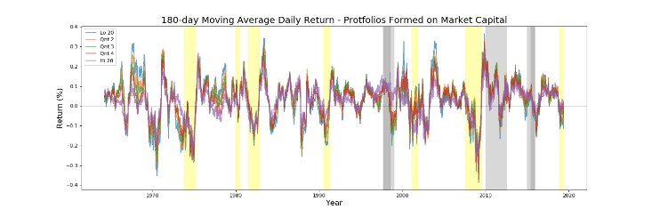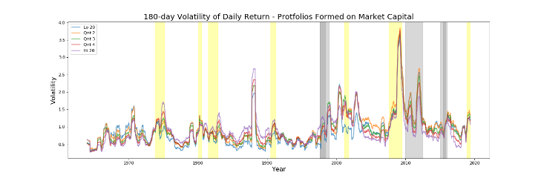

1. ***R Square***

To explore the explanatory power of the five factor model with different size cuts and data frequency, we did regressions with portfolios that cut the equity universe into 3 and 5 and 10 baskets based on market capitalization (size portfolios) and regressed each portfolio’s daily returns and monthly returns on the five factors (thus in total there are $2×3$ groups of regressions) Again, for regressions with daily returns, we adopted half-year rolling windows and for regressions with monthly data, we used 10-year rolling windows. We used the middle point of each rolling window to mark the regression, so that the results represent the model with window centered at that point of time. The graphs below are $R^{2}$ of each type of regressions.

|  |
| --- |
| *Figure n: $R^{2}$ of Time-series regressions in Five Factor Model* |

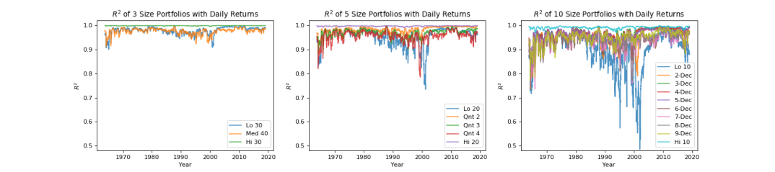

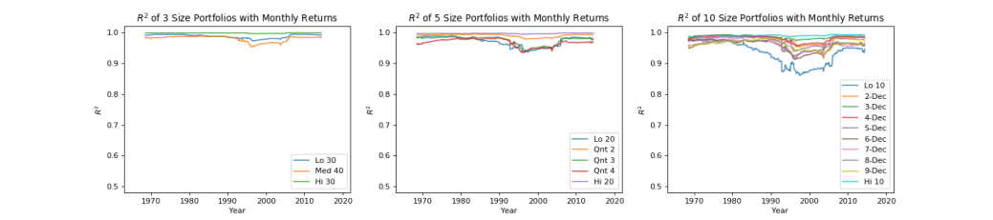

* The five factor model explains the market better with monthly data than with daily data. This observation holds for all time periods and all portfolio cuts. This is intuitive, as monthly data by its nature digests more noise than daily data does. Another observation is that the model with daily data can have higher $R^{2}$ than monthly data when the market is extremely volatile: for example, during the 2008 financial crisis, the daily return volatility reached a historical high and $R^{2}$ of the daily return of 10 size portfolios are less divergent and almost all above 95%, while the $R^{2}$ of monthly returns of 10 size portfolios ranged from 87% to 100%. It means that in severe financial crisis, though the market is more volatile, but stocks with different market capital size tend to move closer together (as shown in moving average return and volatility plots), and probably the market fluctuation or some specific risk reward factor became the major driver of individual stock movements. Thus, we can say that generally, monthly data is easier to explain with five factor model, but during extreme occasions like severe financial crisis, the daily data are explained more by five factor model.
* The finer we cut the universe by size, the more diverge the five factor model’s performance is among size portfolios. For regressions with daily returns, the three size portfolios have very close $R^{2}$ around 95%, the five size portfolios have $R^{2}$ ranged from 75% to 100%, and the ten size portfolios have $R^{2}$ widely ranged from 50% to 100%. For regressions with monthly returns, the divergence is narrower, because generally monthly data is easier to explain as described in the first bullet point. But the divergence is still not negligible: the three size portfolios are closer to 100%, the five size portfolios’ $R^{2}$ are from 95% to 100% and the ten size portfolios’ $R^{2}$ range from 85% to 97%.
* The explanatory power of five factor model is stronger for big-size stock portfolios and weaker for small-size stock portfolios. Similar to the rationale of the first bullet point, the smaller size the listed company is, the more noisy its returns could be, namely more volatile or vulnerable it can be market signals, which could be financial events or policy changes or investors’ sentiments, etc., and thus more difficult it is to explain them as a uniformed portfolio with only five factors.
* Despite the largest-size stocks, the explanatory powers of five factor model on portfolios tend to move closely together. Based on the trend of the $R^{2}$, we can divide the history into four periods: the first one is before 1990 when the $R^{2}$ of five factor model was stable; the second one is from 1993 to 2000, the explanatory power of five factor model declined after Fama and French firstly introduced the three factor model in 1993; the third period is from 2000 to 2014, when the $R^{2}$ surged quickly back and remained at a high level; and the last period is post 2014 when Fama and French released the five factor model, the $R^{2}$ started to drop again. A research by BlackRock on the factor investment revealed that from 2011 to 2014, the asset under management (AUM) of factor investment doubled, and from 2014 to 2017, the AUM of factor investment increased by 44% (Ang 2018). It is one of our hypotheses that the heavy use of the factor model as investment and trading strategies could artificially compress the risk rewards on size, B/M ratio, profitability and firms’ investment returns, and thus dilute the explaining power of five factors.

1. ***Explanatory power of each factor***

The $R^{2}$ of five factor model are generally very high. However, we observed that not all the five factors are statistically significant all the time. The plots below showed a binary indicator of whether the factor is significant at 95% level (1 stands for p-value < 0.05) in regressions with daily returns and half-year rolling windows. Here we use the 3 size portfolios as an example.

|  |
| --- |
| *Figure n:*  *Significance Occurrence of Five Factors (Daily Return)* |

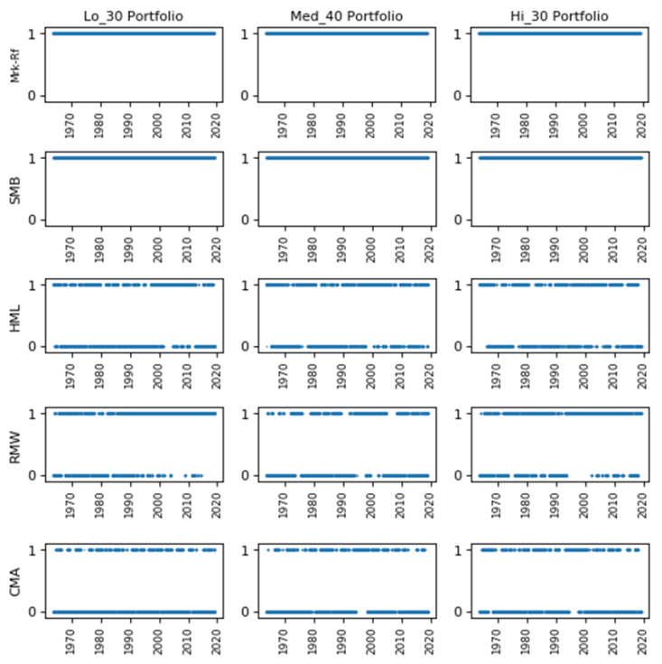

It can be seen that the market excess return and SMB are always significant in any of the three portfolios. As summarized in the heat-map below, HML is significant around 50% of the time. RMW is significant ~65% of the time for the low size portfolio and high size portfolio, but is interpretative for the middle band size portfolio. CMA is a factor that have the least significance occurrence: significant for only 30% of the time. g

|  |
| --- |
| *Figure n:*  *% of significance occurrence of factors (daily data)* |

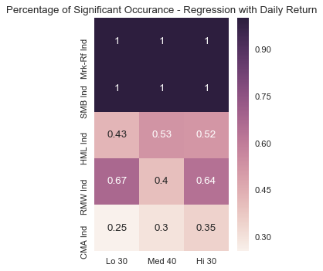

Also, it can be observed from the plot that when a factor is significant for one size portfolio, it is not necessary that it is also significant for the other size portfolios. That is to say, different size portfolios may have movements contributed to different factors in the same period of time.

RMW, which measures the risk rewards on firm’s profitability, are more significant during the 2008 financial crisis for the low size companies, which means that during that time, the robustness of a small company’s profitability is an important factor for the company’s stock performance.

1. ***Correlation between factors***

Although the five factors are not always significant, it is very likely that the insignificant factor was well represented by other significant factors, considering the high correlations among the five factors by nature. Thus, we then looked at the correlation among the five factors by firstly doing OLS regression of each factor on the rest four through the whole time horizon. And in order to further explore whether the correlation patterns are different under different scenarios, we then did similar regressions but segment the history by months when S&P 500 or the target size portfolio had positive monthly returns and negative monthly returns, and by bull and bear markets. Finally, we also examine the Pearson correlation between factors on a rolling window basis.

* 1. *Regression on the whole time horizon*

As shown in Figure n below, with both monthly data and daily data, the five factors present tight correlations. With monthly data, all factors except for HML bring in statistically significant extra returns (reflected by the constant term) beyond the parts that can be explained by the other four factors. Take the market excess return as an example, except the portion that explained by SMB, RMW and CMA, it still contains 0.79% of monthly return that are unexplained to other factors. HML is the only factor that does not have a statistically significant constant term, which are consistent with the conclusion that HML is redundant by a lot of research papers.

|  |
| --- |
| *Figure n: Regression among 5 Factors with monthly data* |

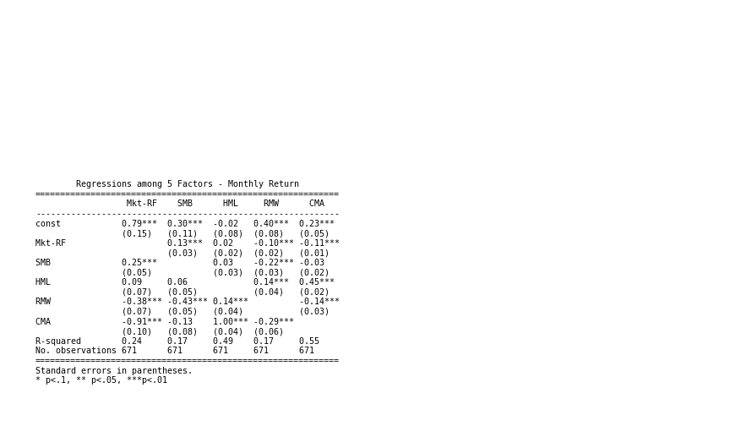

However, if we shift to daily data, the HML factor is saved, and actually all the five factors have statistically significant constant terms. And we can say that with daily data, the five factors are more tightly correlated with each other in terms that in each of the regression, all the four factors are always significant simultaneously. However, compared with monthly data, the $R^{2}$ with daily data a slightly lower, which can contribute to more noise in the daily data.

|  |
| --- |
| *Figure n: Regression among 5 Factors with daily data* |

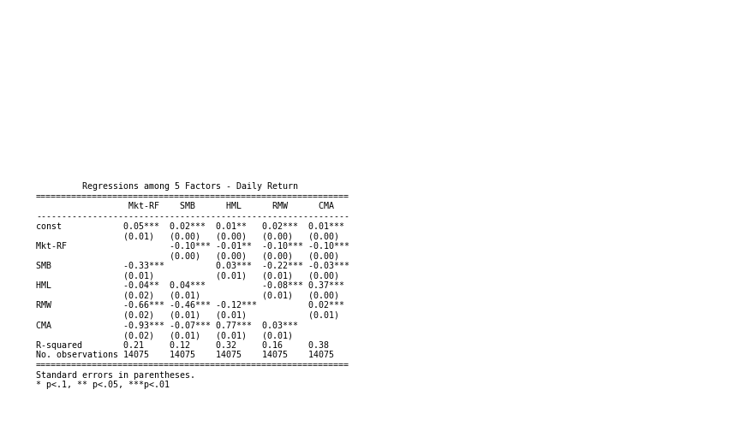

* 1. *Positive V.S. Negative Month*

We divided the history into two buckets, one is the months when S&P 500 index or the target size portfolio had positive returns and the other is the opposite months.

Figure n below summarized the regressions of three size factors when they have positive/negative monthly returns on the five factors. HML and RMW are not significant to the Low 30% size portfolio when it had negative monthly returns, and CMA is insignificant for any portfolios and any of the two scenarios. For all the three portfolios, the coefficient is larger in the negative-return periods than in the positive-return periods. SMB’s coefficient in positive and negative-return periods are similar for each portfolio. Another interesting observation is that HML and RMW will have coefficients in opposite sign in positive and negative-return periods. For HML, it implies that market’s reward on risks that contribute to B/M ratio tends to bring extra positive/negative returns during positive/negative-return months. And similar for RMW, which measures market’s reward on risks that contribute to robustness of the firms’ profitability. Besides, the constant terms for all the regressions are significant, negative and large in magnitude, which means that there are variations that are not captured by the five factors, which tend to overstate positive returns and understate negative returns.

|  |
| --- |
| *Figure n:*  *Regression by Positive/Negative S&P500 Return Months* |

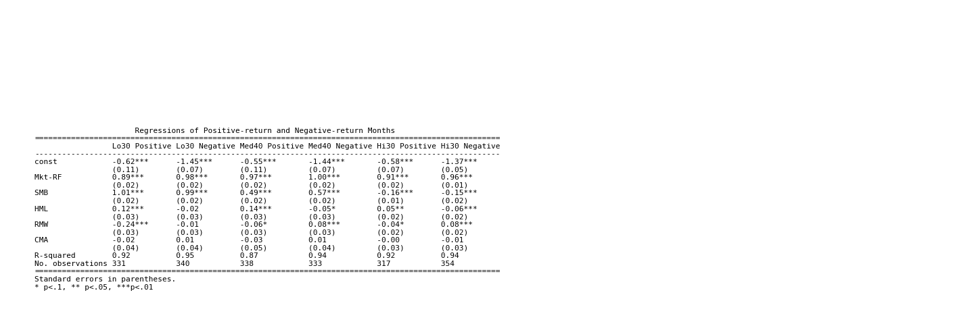

Figure n and n below show the correlations among the five factors by regressing each one of the factor on the other four during S&P 500’s positive-return months and negative-return months respectively.

* It can be seen that HML is redundant in both the positive-return scenario and the negative-return scenario. And CMA is redundant in the negative-return scenario.
* The five factors are tightly correlated to each other, and the correlations are stronger in the positive-month scenario.
* In the positive-return scenario, the coefficient of market excess return is always negative, and equivalently all the coefficients are negative in the regression of market excess return. The interpretation is the better risk appetite on firms’ profitability and investment return will help the market boom further (or the causal relationship can be the other way round). But risk appetite for firm size seems to effect in an opposite way.
* In the negative-return scenario, the less risk appetite on firms’ size, B/M ratio and investment return tends to relieve some market downturn pressure (or it is the market downturn makes investors risk averse towards riskier firms with small size, low B/M ratio and aggressive investment).

|  |
| --- |
| *Figure n:*  *Regression among Factors in positive S&P500 return months* |

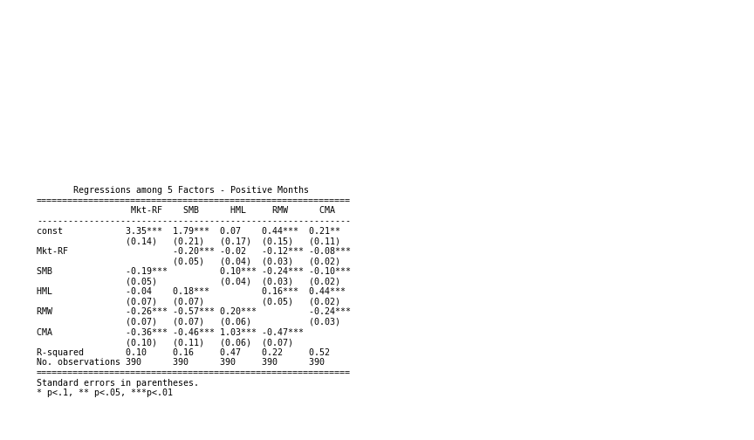

|  |
| --- |
| *Figure n:*  *Regression among Factors in negative S&P500 return months* |

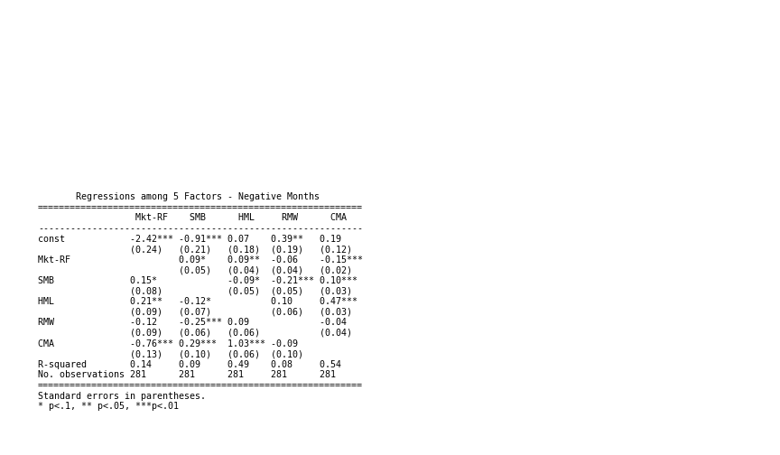

* 1. *Bull V.S. Bear market*

We also did an analysis parallel to the above one but based on bull and bear markets with daily data. A bull market is most commonly defined as a 20% S&P 500 rally after a 20% drop and before a second 20% decline in terms of S&P 500’s closing price.

In Figure n below, contrary to the positive-return and negative return scenarios, regressions in the bull and bear scenario mostly have insignificant and almost zero constant terms, which means that the five factors explained the portfolio return variations more comprehensively if we segment the history by bull and bear market scenarios and use daily data. Besides, the market excess return and SMB tend to have non-distinguishable coefficients in a bull and bear markets for each portfolio. For the Medium 40% portfolio, HML and CMA mostly determined the different performance in bull and bear market. And for the Low 30% portfolio, HML and RMW are the major contributor. The High 30% portfolio’s performance does not seem to be affected much by these risk rewards.

|  |
| --- |
| *Figure n: Regression by Bull/Bear periods (daily data)* |

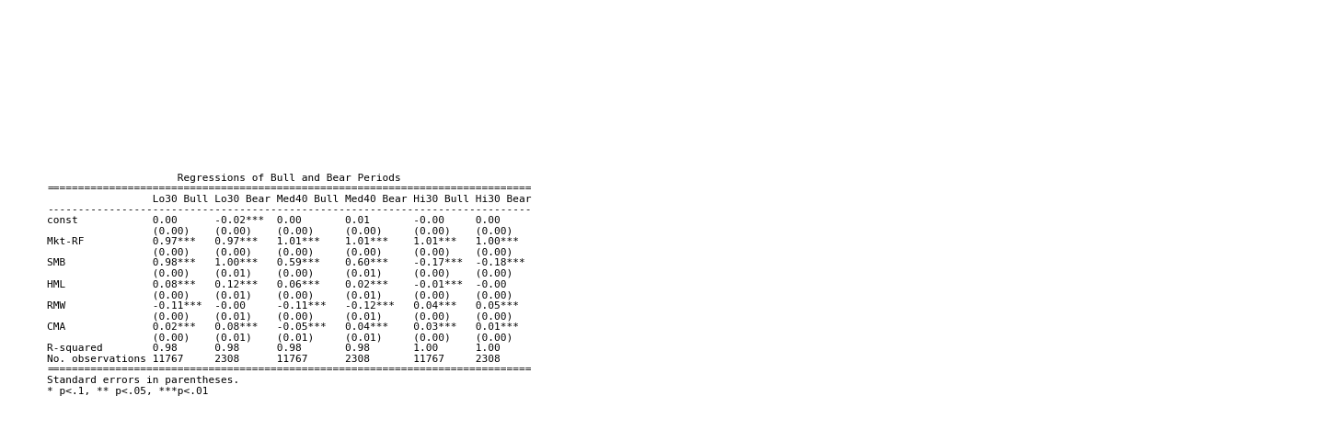

Figure n and n are summaries of the correlation between factors in bull and bear market scenarios respectively. HML again seems to be redundant in both bull and bear scenarios. But different from the positive/negative-month scenarios, RMW is redundant in the bear scenario, but CMA is not in both bull and bear scenarios. The take-away of how the risk appetite affects the market returns in bull and bear scenarios (or how the market scenarios affects investors’ risk appetites) is similar to that in the positive/negative-month scenarios.

|  |
| --- |
| *Figure n: Regression among Factors in Bull Periods* |

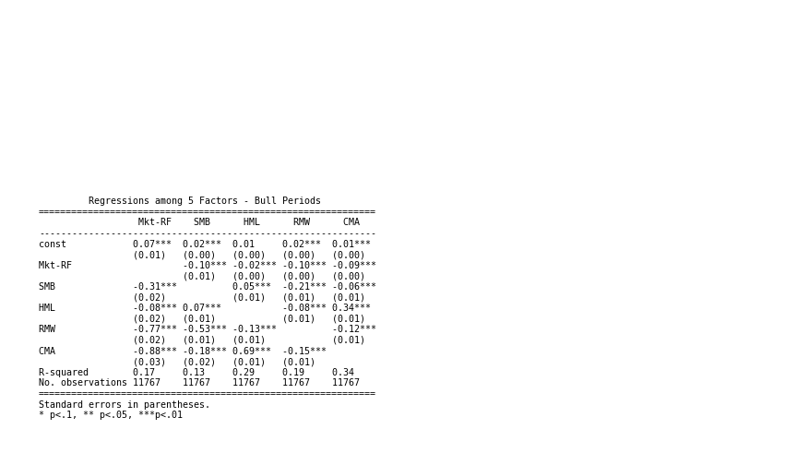

|  |
| --- |
| *Figure n: Regression among Factors in Bear Periods* |

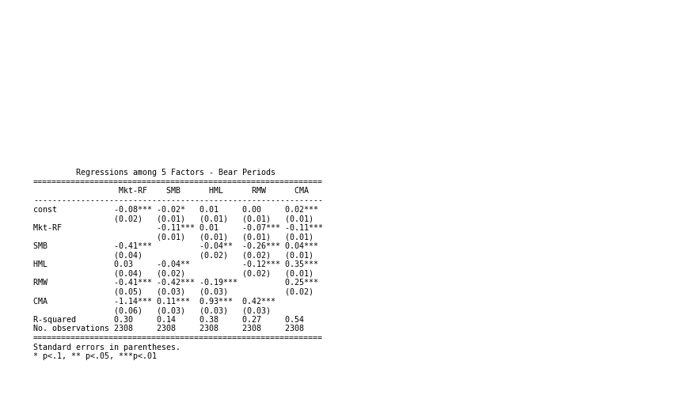

* 1. *Pearson Correlation between factors over time*

To better observe the correlation between the factors on pair wise and how the correlation vary over time, we calculated the Pearson correlation between each pair of factor on a rolling window basis with daily data. 1995 seems to be a year when the correlations between factors shifted dramatically. Some factors may even have correlation turned from negative to positive or the other way round since 1995. 2008 financial crisis seems to be another turning point of some correlations.

|  |
| --- |
| *Figure n: Pearson Correlation among 5 Factors* |

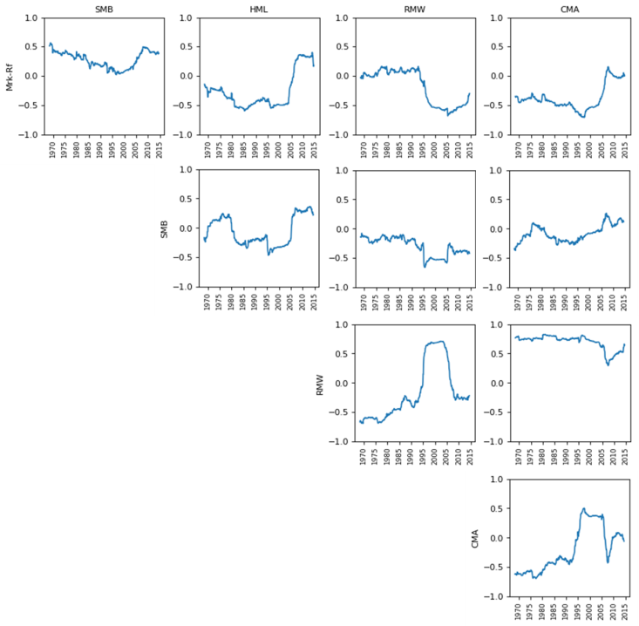

***Our Future Plan***

# References

Ang, Andrew. 2018. June 5. https://www.blackrock.com/us/individual/investment-ideas/what-is-factor-investing/factor-commentary/andrews-angle/factor-growth.

Francis Breedon, Louisa Chen, Angelo Ranaldo, Nicholas Vause. 2018. *Judgement Day: algorithmic trading around the Swiss franc cap removal.* Bank of England.

Irwin, Neil. 2011. September 30. https://www.washingtonpost.com/business/economy/us-economic-recovery-tied-to-european-debt-crisis/2011/09/29/gIQAAIAEBL_story.html?noredirect=on&utm_term=.d29ea3b844cd.

Stracca, Livio. 2013. *The Global Effects of the Euro Debt Crisis.* European Central Bank.